Unit 10: communication Technology

P4 - Describe what ‘Data Elements’ **are** and **why** they are important?

**From End to End**

***The scenario:***   
Mr Evans owns a small office which prints leaflets and cards. He wants to learn more about communication technologies and eventually create a small network to connect his computers together. You have been asked to present information on data elements.

***So what are Data Elements?***

*In order for data to be transmitted from one network device to another, data is constructed into data elements. Within the OSI model the data is required to go through a number of processes (each layer has an important role in preparing the data in order for it to be successfully transmitted to the next layer in the sequence and thereafter to the destination device).*

Data Elements fall into two categories:

* **Checksum** eg **cyclic redundancy check (CRC)**
* **Encapsulation** eg frames, packets
* **Datagrams**
* **addresses**
* **sequence numbers**

(Any terms in **bold** is compulsory)

**Keywords**

Important addition – please ensure you include the Keywords section within your assignment and ensure you include any terms/keywords within this section and use for future reference. SEE BELOW:

**Keywords:**

**TCP (Transmission control protocol)**

**UDP (User Datagram protocol)**

**Data Elements**

**Encapsulation -** the condition of being enclosed (as in a capsule

**Decapsulation -** the act or process of decapsulating

Diagrams to help you understand the role of Data Elements within the OSI Model.

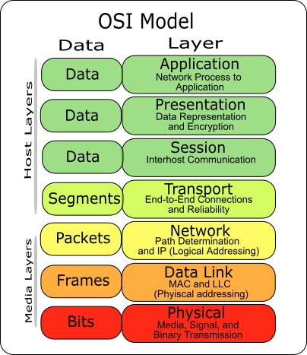

***Introduction***

***Main body of assignment***

In this section you are required to explain the following in relative detail. You should try and incorporate relevant diagrams to support your research. Remember to have a look at the following video: <http://youtu.be/Kb4hVvlCx40>

Data Elements fall into two categories:

* **Checksum** eg **cyclic redundancy check (CRC)**
* **Encapsulation** eg frames, packets
* **Datagrams**
* **addresses**
* **sequence numbers**

(Any terms in **bold** is compulsory)

***Reference page***

BTEC Book: Pages 328-331

<http://youtu.be/Ywxa1pzgC2E>

<http://youtu.be/Kb4hVvlCx40>

<http://www.howstuffworks.com/osi.htm>

<http://youtu.be/zyL1Fud1Z1c>